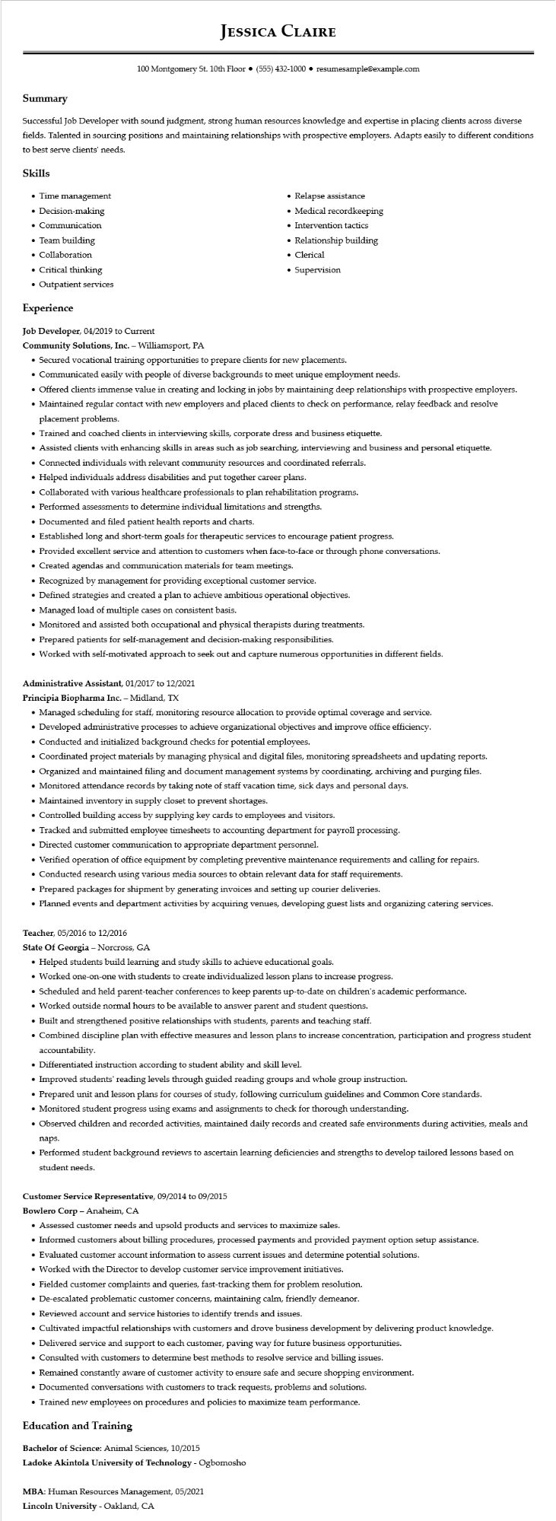
JESSICA CLAIRE
100 Montgomery St. 10th Floor (555) 432-1000⚫ resumesample@example.com
Summary
Successful Job Developer with sound judgment, strong human resources knowledge and expertise in placing clients across diverse fields. Talented in sourcing positions and maintaining relationships with prospective employers. Adapts easily to different conditions to best serve clients' needs.
Skills
• Time management
• Decision-making
• Communication
• Team building
• Collaboration
• Critical thinking
• Outpatient services
Experience
Job Developer, 04/2019 to Current
Community Solutions, Inc. - Williamsport, PA
• Relapse assistance
• Medical recordkeeping
• Intervention tactics
• Relationship building • Clerical
• Supervision
• Secured vocational training opportunities to prepare clients for new placements.
• Communicated easily with people of diverse backgrounds to meet unique employment needs.
• Offered clients immense value in creating and locking in jobs by maintaining deep relationships with prospective employers.
• Maintained regular contact with new employers and placed clients to check on performance, relay feedback and resolve placement problems.
• Trained and coached clients in interviewing skills, corporate dress and business etiquette.
• Assisted clients with enhancing skills in areas such as job searching, interviewing and business and personal etiquette.
• Connected individuals with relevant community resources and coordinated referrals.
• Helped individuals address disabilities and put together career plans.
• Collaborated with various healthcare professionals to plan rehabilitation programs.
• Performed assessments to determine individual limitations and strengths.
• Documented and filed patient health reports and charts.
• Established long and short-term goals for therapeutic services to encourage patient progress.
• Provided excellent service and attention to customers when face-to-face or through phone conversations.
• Created agendas and communication materials for team meetings.
• Recognized by management for providing exceptional customer service.
• Defined strategies and created a plan to achieve ambitious operational objectives.
• Managed load of multiple cases on consistent basis.
• Monitored and assisted both occupational and physical therapists during treatments.
• Prepared patients for self-management and decision-making responsibilities.
• Worked with self-motivated approach to seek out and capture numerous opportunities in different fields.
Administrative Assistant, 01/2017 to 12/2021
Principia Biopharma Inc. - Midland, TX
• Managed scheduling for staff, monitoring resource allocation to provide optimal coverage and service.
• Developed administrative processes to achieve organizational objectives and improve office efficiency.
• Conducted and initialized background checks for potential employees.
• Coordinated project materials by managing physical and digital files, monitoring spreadsheets and updating reports.
• Organized and maintained filing and document management systems by coordinating, archiving and purging files.
• Monitored attendance records by taking note of staff vacation time, sick days and personal days.
• Maintained inventory in supply closet to prevent shortages.
• Controlled building access by supplying key cards to employees and visitors.
• Tracked and submitted employee timesheets to accounting department for payroll processing.
• Directed customer communication to appropriate department personnel.
• Verified operation of office equipment by completing preventive maintenance requirements and calling for repairs.
• Conducted research using various media sources to obtain relevant data for staff requirements.
• Prepared packages for shipment by generating invoices and setting up courier deliveries.
• Planned events and department activities by acquiring venues, developing guest lists and organizing catering services.
Teacher, 05/2016 to 12/2016
State of Georgia - Norcross, GA
• Helped students build learning and study skills to achieve educational goals.
• Worked one-on-one with students to create individualized lesson plans to increase progress.
• Scheduled and held parent-teacher conferences to keep parents up-to-date on children's academic performance.
• Worked outside normal hours to be available to answer parent and student questions.
• Built and strengthened positive relationships with students, parents and teaching staff.
• Combined discipline plan with effective measures and lesson plans to increase concentration, participation and progress student accountability.
• Differentiated instruction according to student ability and skill level.
• Improved students' reading levels through guided reading groups and whole group instruction.
• Prepared unit and lesson plans for courses of study, following curriculum guidelines and Common Core standards.
• Monitored student progress using exams and assignments to check for thorough understanding.
• Observed children and recorded activities, maintained daily records and created safe environments during activities, meals and naps.
• Performed student background reviews to ascertain learning deficiencies and strengths to develop tailored lessons based on student needs.
Customer Service Representative, 09/2014 to 09/2015
Bowlero Corp - Anaheim, CA
• Assessed customer needs and upsold products and services to maximize sales.
• Informed customers about billing procedures, processed payments and provided payment option setup assistance.
• Evaluated customer account information to assess current issues and determine potential solutions.
• Worked with the Director to develop customer service improvement initiatives.
• Fielded customer complaints and queries, fast-tracking them for problem resolution.
• De-escalated problematic customer concerns, maintaining calm, friendly demeanor.
• Reviewed account and service histories to identify trends and issues.
• Cultivated impactful relationships with customers and drove business development by delivering product knowledge.
• Delivered service and support to each customer, paving way for future business opportunities.
• Consulted with customers to determine best methods to resolve service and billing issues.
• Remained constantly aware of customer activity to ensure safe and secure shopping environment.
• Documented conversations with customers to track requests, problems and solutions.
• Trained new employees on procedures and policies to maximize team performance.
Education and Training
Bachelor of Science: Animal Sciences, 10/2015
Ladoke Akintola University of Technology - Ogbomosho
MBA: Human Resources Management, 05/2021
Lincoln University - Oakland, CA

